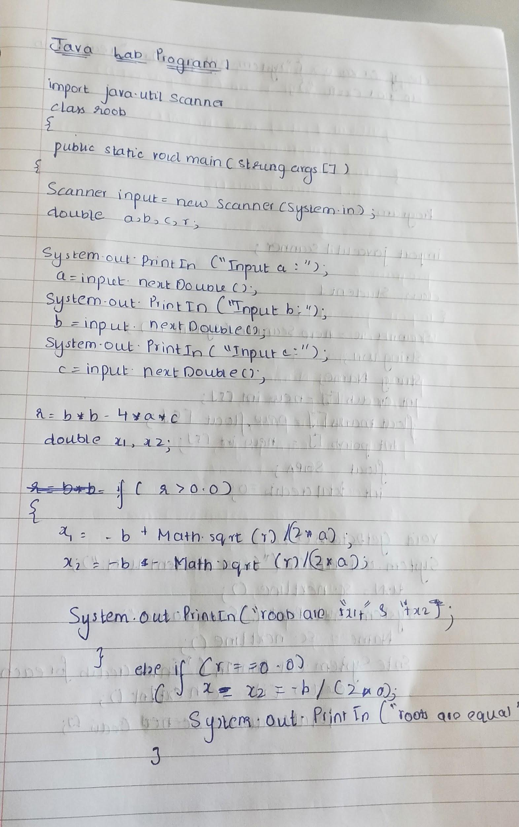

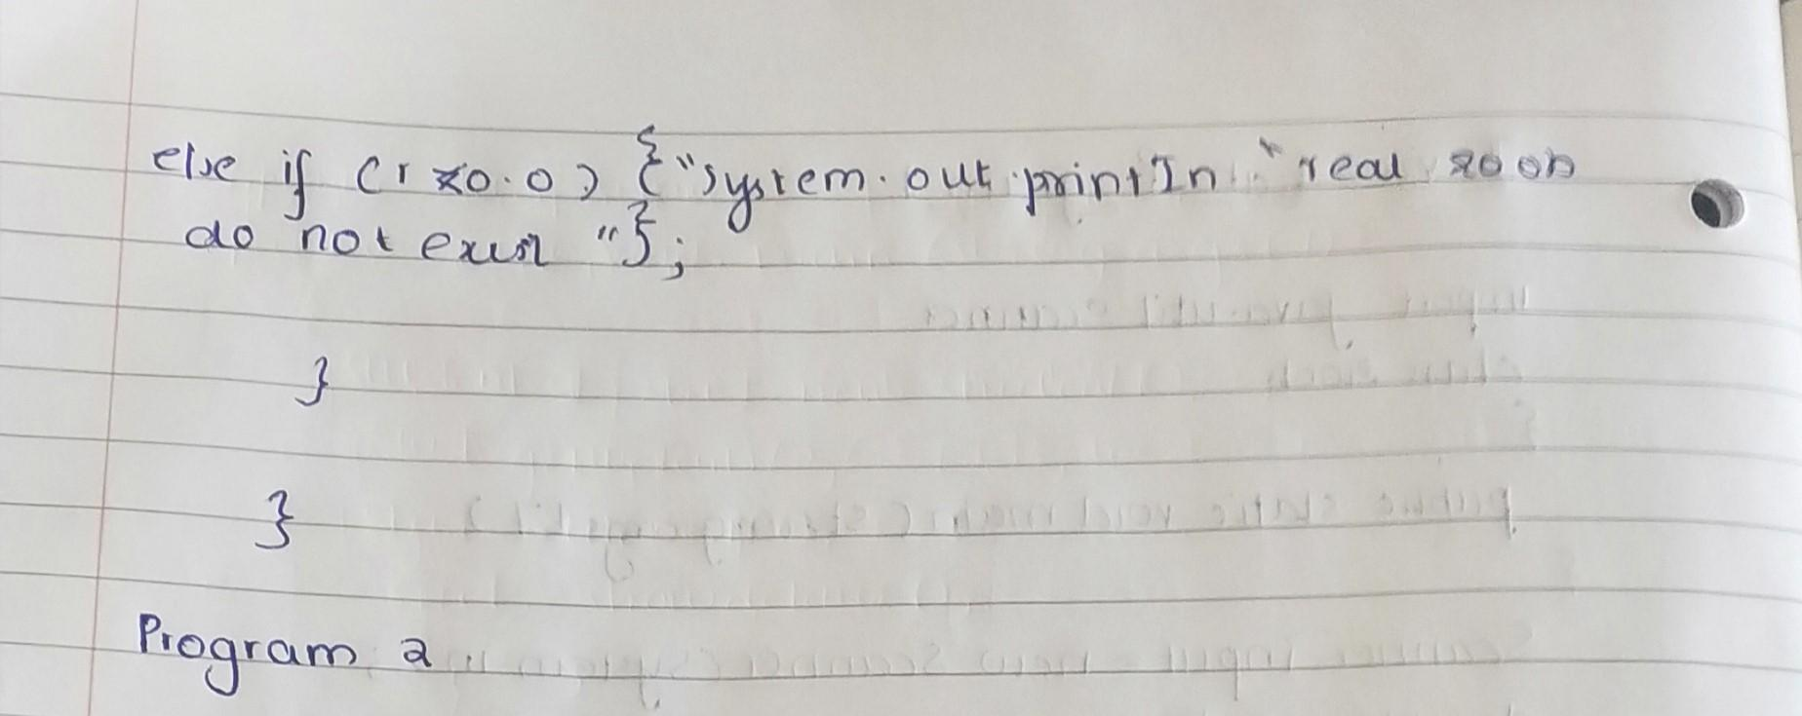

import java.util.Scanner;

class roots{

public static void main(String [] args){

Scanner input = new Scanner(System.in);

double a,b,c,r;

System.out.println("Input a: ");

a = input.nextDouble();

System.out.println("Input b: ");

b = input.nextDouble();

System.out.println("Input c: ");

c = input.nextDouble();

r=b*b-4.0*a*c;

double x1,x2;

if(r>0.0)

{ x1 = -b + Math.sqrt(r) / (2 * a);

x2 = -b - Math.sqrt(r) / (2 * a);

System.out.println("roots are : "+x1+" & "+x2);

}

else if(r==0.0)

{ x1 = x2=-b / (2 * a);

System.out.println("roots are equal");

}

else if(r<0.0){ System.out.println("it has no real roots");}

}

}

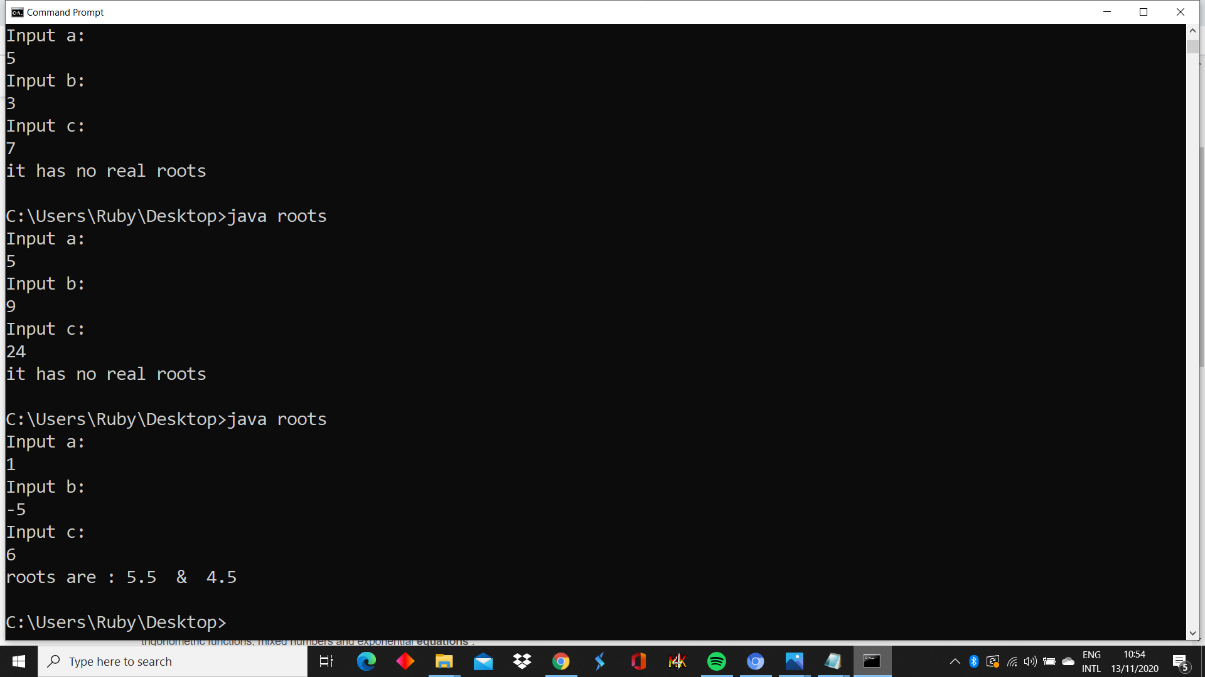

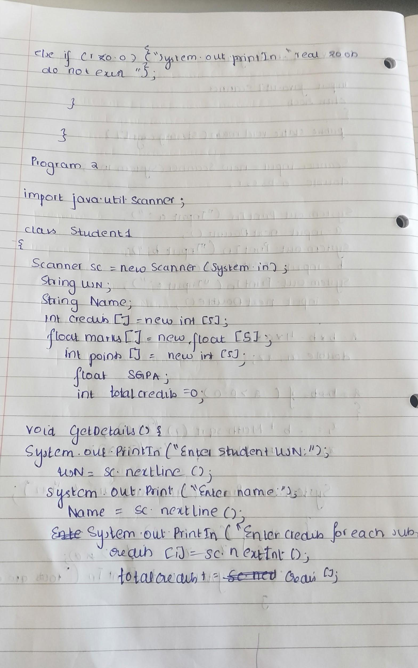

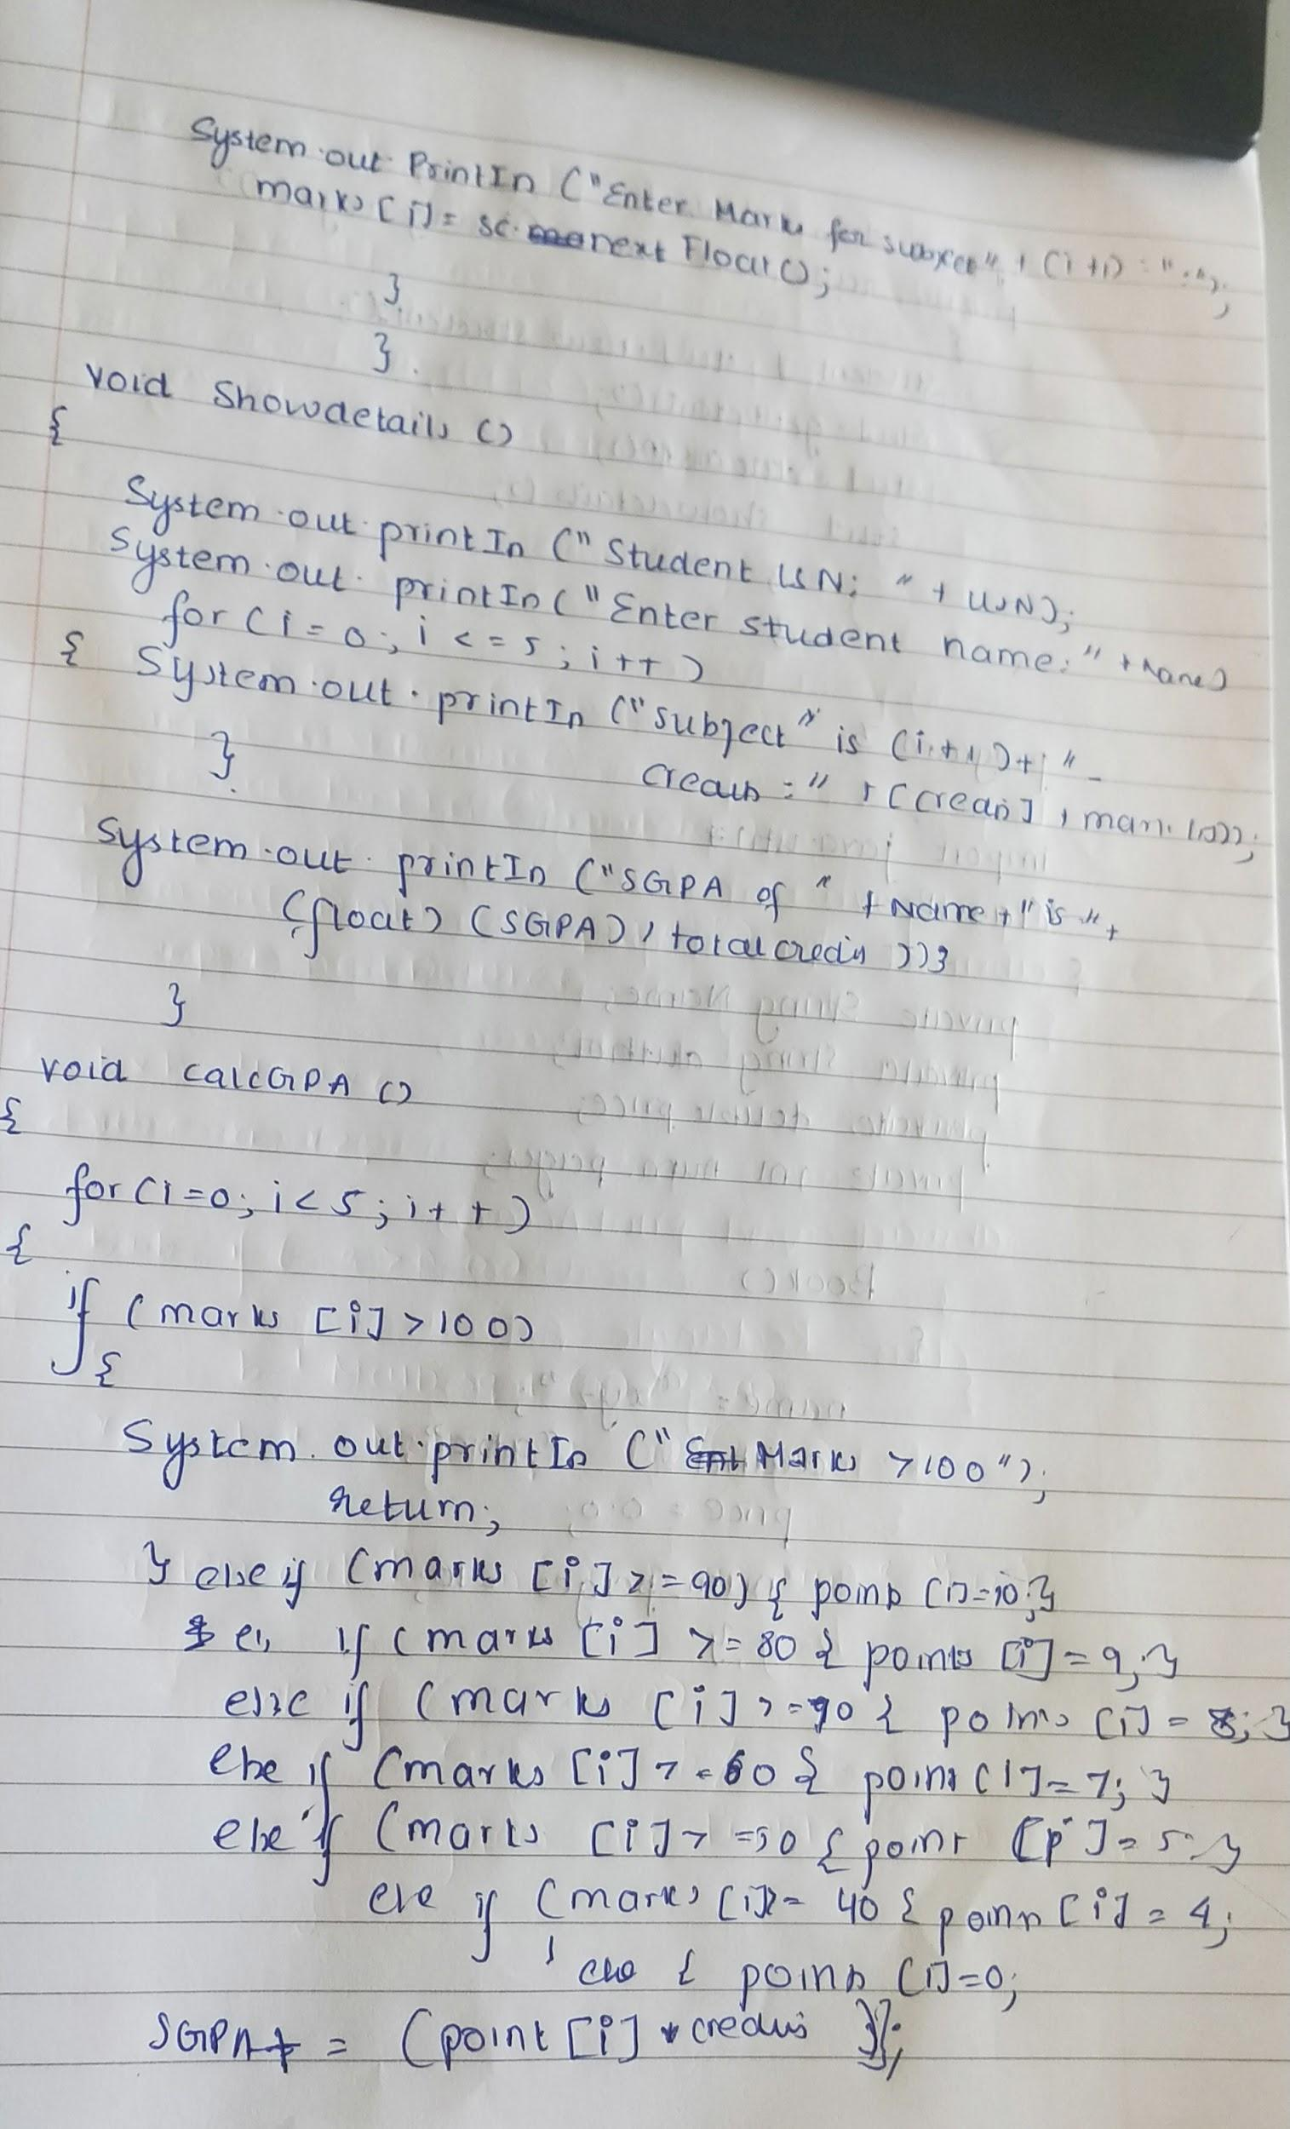

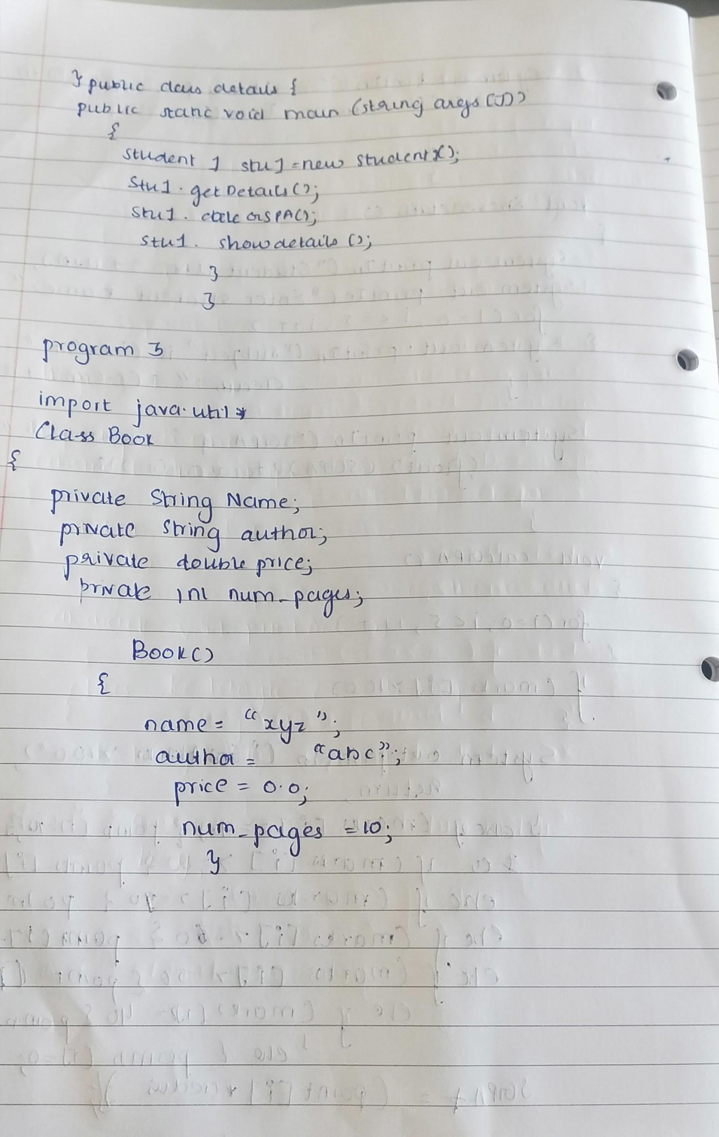

import java.util.Scanner;

class Student1{

Scanner sc = new Scanner(System.in);

String USN;

String Name;

int credits[] = new int[5];

float marks[] = new float[5];

int points[] = new int[5];

float SGPA;

int totalCredits = 0;

void getDetails(){

System.out.println("Enter student USN: ");

USN = sc.nextLine();

System.out.println("Enter student Name: ");

Name = sc.nextLine();

for(int i=0;i<5;i++){

System.out.println("Enter CREDITS for Subject " + (i+1) + ": ");

credits[i] = sc.nextInt();

totalCredits += credits[i];

System.out.println("Enter MARKS for Subject " + (i+1) + ": ");

marks[i] = sc.nextFloat();

}

}

void showDetails(){

System.out.println("Student USN: " + USN);

System.out.println("Enter student name: " + Name);

for(int i=0;i<5;i++){

System.out.println("Subject " + (i+1) + " - Credits: " + credits[i] + " - Marks: " + marks[i]);

}

System.out.println("SGPA of " + Name + " is: " + (float)(SGPA/totalCredits));

}

void calcSGPA(){

for(int i = 0;i<5;i++){

if(marks[i] > 100){

System.out.println("Error: Marks are above 100");

return;

}else if(marks[i] >= 90){

points[i] = 10;

}else if(marks[i] >= 80){

points[i] = 9;

}else if(marks[i] >= 70){

points[i] = 8;

}else if(marks[i] >= 60){

points[i] = 7;

}else if(marks[i] >= 50){

points[i] = 5;

}else if(marks[i] >= 40){

points[i] = 4;

}else{

points[i] = 0;

}

SGPA += (points[i]*credits[i]);

}

}

}

public class lab2 {

public static void main(String args[]) {

Student1 stu1 = new Student1();

stu1.getDetails();

stu1.calcSGPA();

stu1.showDetails();

}

}

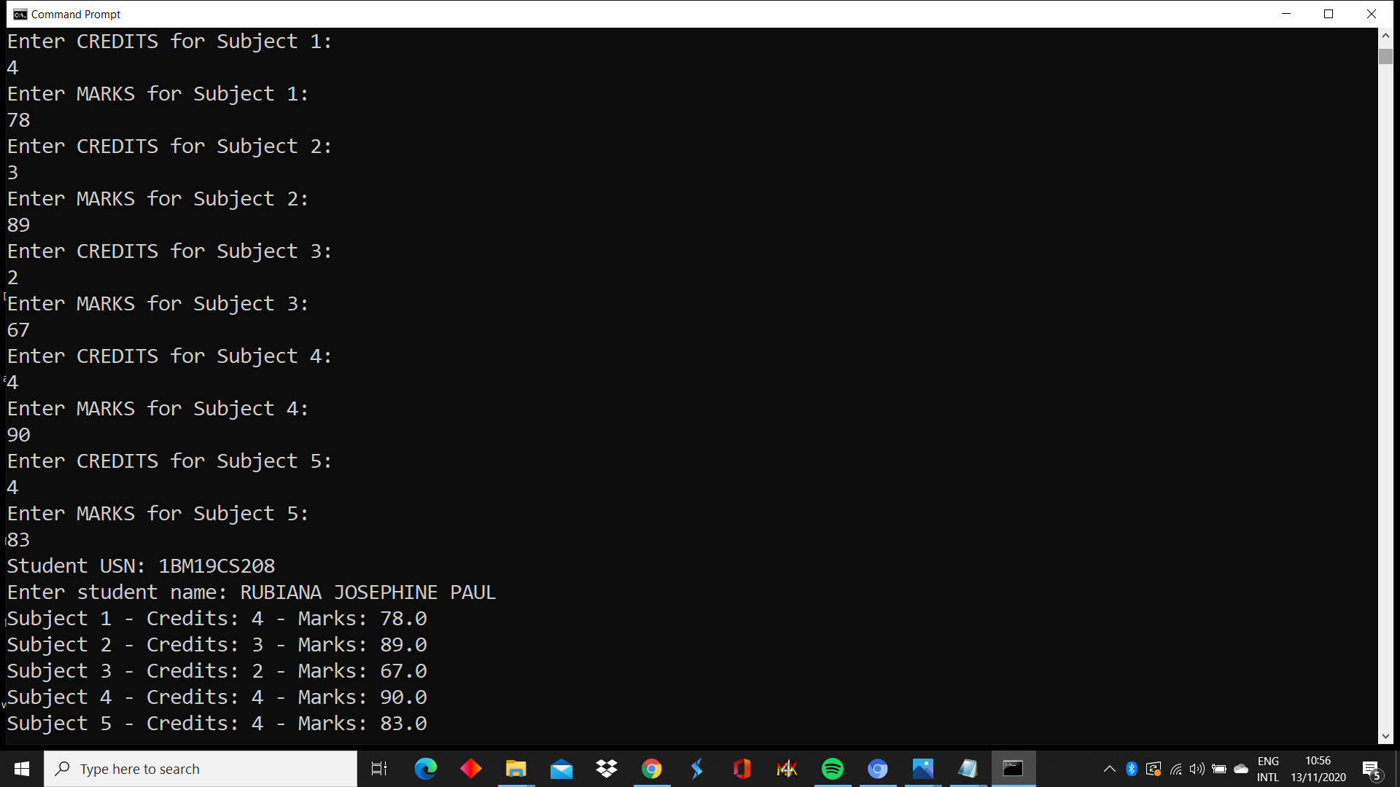

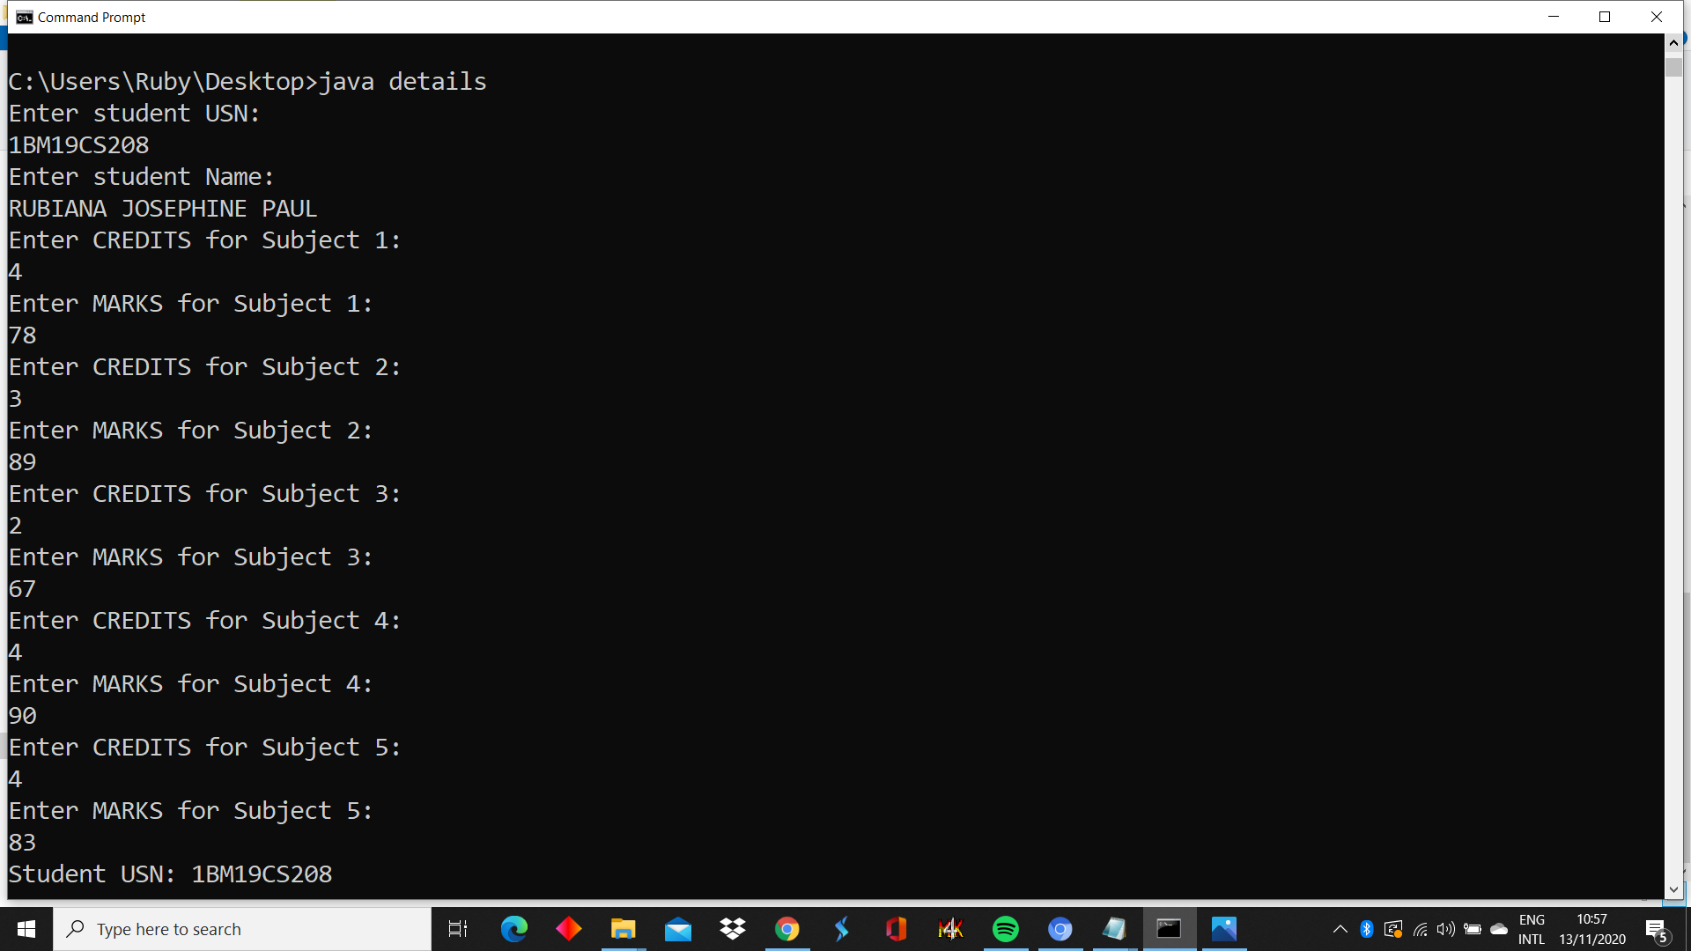



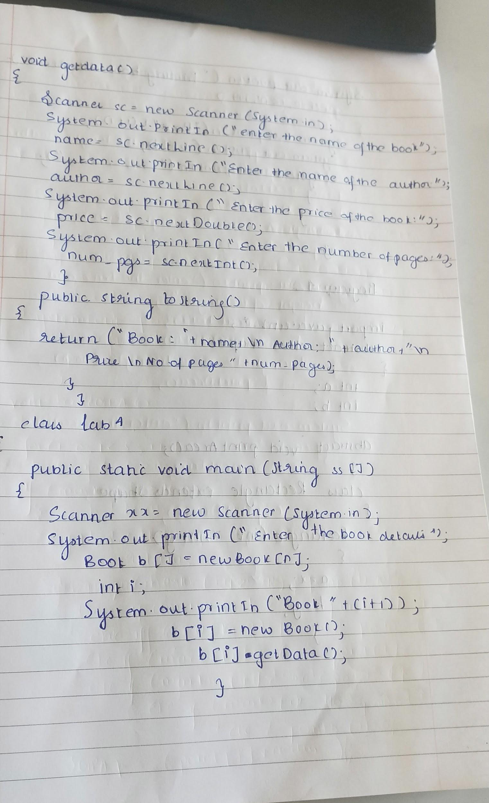

import java.util.*;

class Book

{

private String name;

private String author;

private double price;

private int num_pages;

Book()

{

name="fault in our stars";

author="john green";

price= 7.0;

num_pages=150;

}

void indata()

{

Scanner sc= new Scanner(System.in);

System.out.println("enter the name of book");

name = sc.nextLine();

System.out.println("enter the name of author");

author = sc.nextLine();

System.out.println("enter the price of book");

price = sc.nextDouble();

System.out.println("enter the number of pages");

num_pages = sc.nextInt();

}

public String toString()

{

return("Book: "+name+"\nAuthor: "+author+"\nPrice: Rs "+price+"\nNo.of pages: "+num_pages);

}

}

class lab5

{

public static void main(String ss[])

{

Scanner xx=new Scanner(System.in);

System.out.println("Enter the no of books:");

int n=xx.nextInt();

Book b[]=new Book[n];

int i;

System.out.println("Enter the book details");

for(i=0;i<n;i++)

{

System.out.println("Book "+(i+1));

b[i]=new Book();

b[i].indata();

}

System.out.println("Printing book details....");

for(i=0;i<n;i++)

{

System.out.println("Book "+(i+1));

System.out.println(b[i]);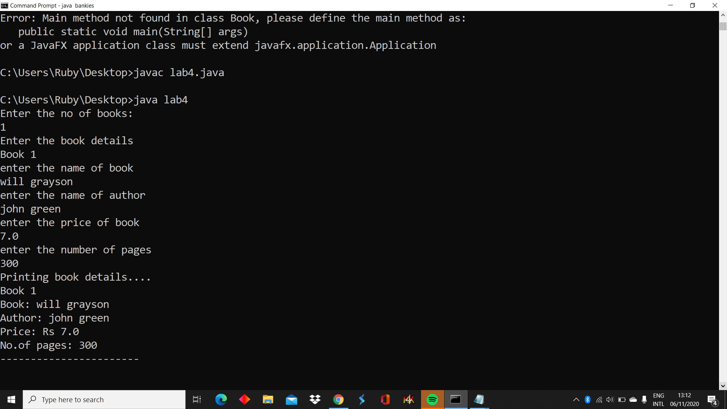

System.out.println("-----------------------");

}

}

}

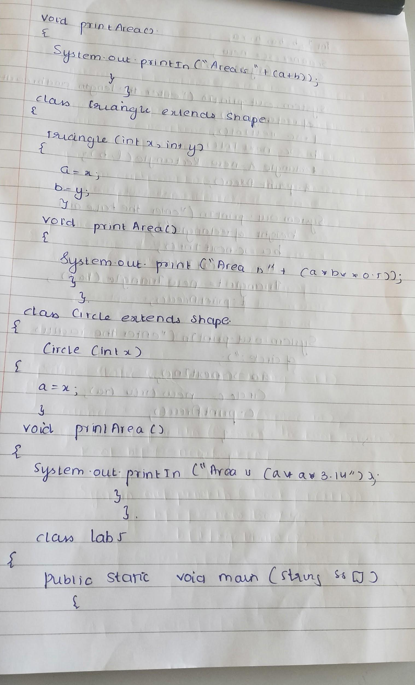

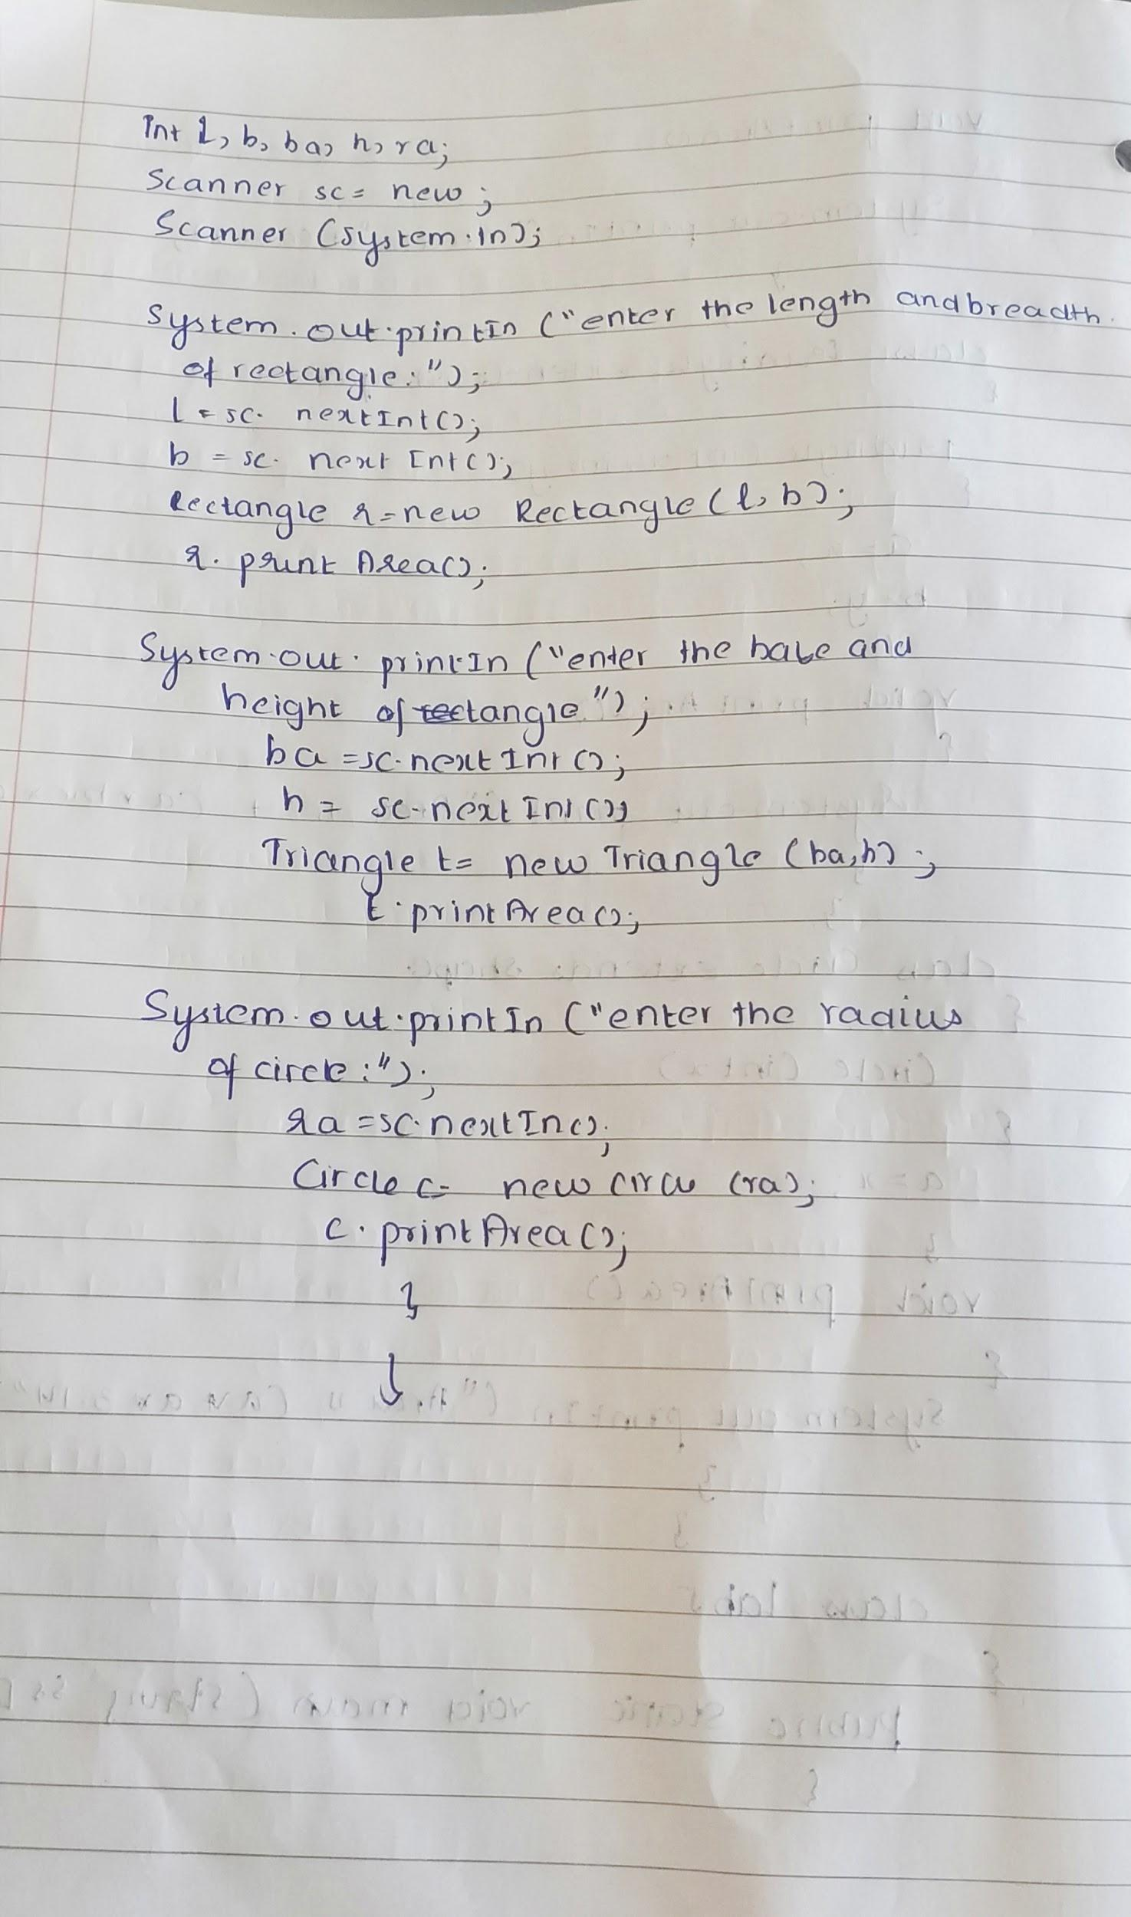

import java.util.*;

abstract class Shape

{

int a;

int b;

abstract void printArea();

}

class Rectangle extends Shape

{

Rectangle(int x, int y)

{

a=x;

b=y;

}

void printArea()

{

System.out.println("Area is "+(a*b));

}

}

class Triangle extends Shape

{

Triangle(int x, int y)

{

a=x;

b=y;

}

void printArea()

{

System.out.println("Area is "+(a*b*0.5));

}

}

class Circle extends Shape

{

Circle(int x)

{

a=x;

}

void printArea()

{

System.out.println("Area is "+(a*a*3.14));

}

}

class lab5

{

public static void main(String ss[])

{

int l,b,ba,h,ra;

Scanner sc = new Scanner(System.in);

System.out.println("enter the length and breadth of rectangle");

l= sc.nextInt();

b= sc.nextInt();

Rectangle r= new Rectangle(l,b);

r.printArea();

System.out.println("enter the base and height of triangle");

ba= sc.nextInt();

h= sc.nextInt();

Triangle t = new Triangle(ba,h);

t.printArea();

System.out.println("enter the radius of circle");

ra= sc.nextInt();

Circle c = new Circle(ra);

c.printArea();

}

}

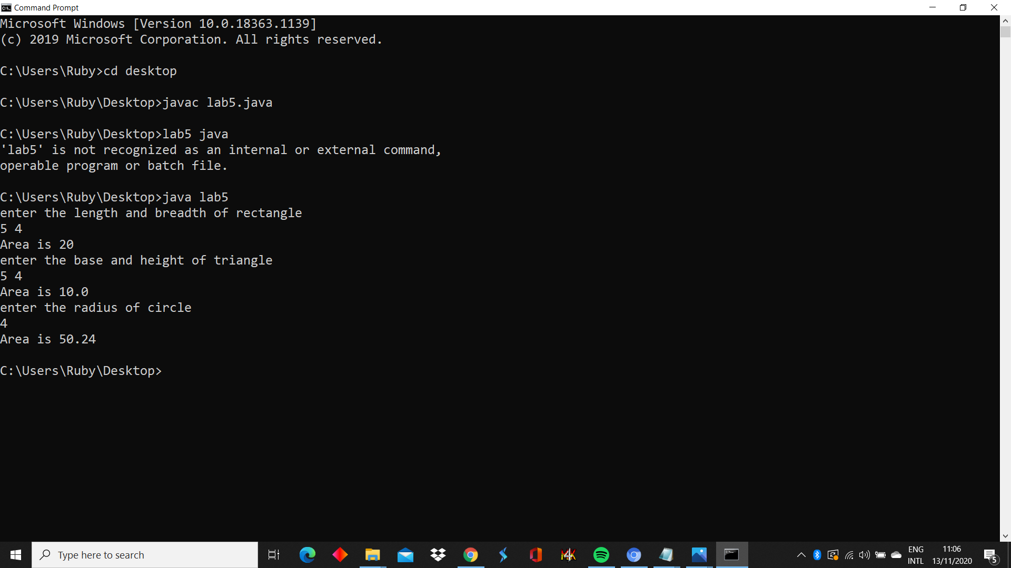

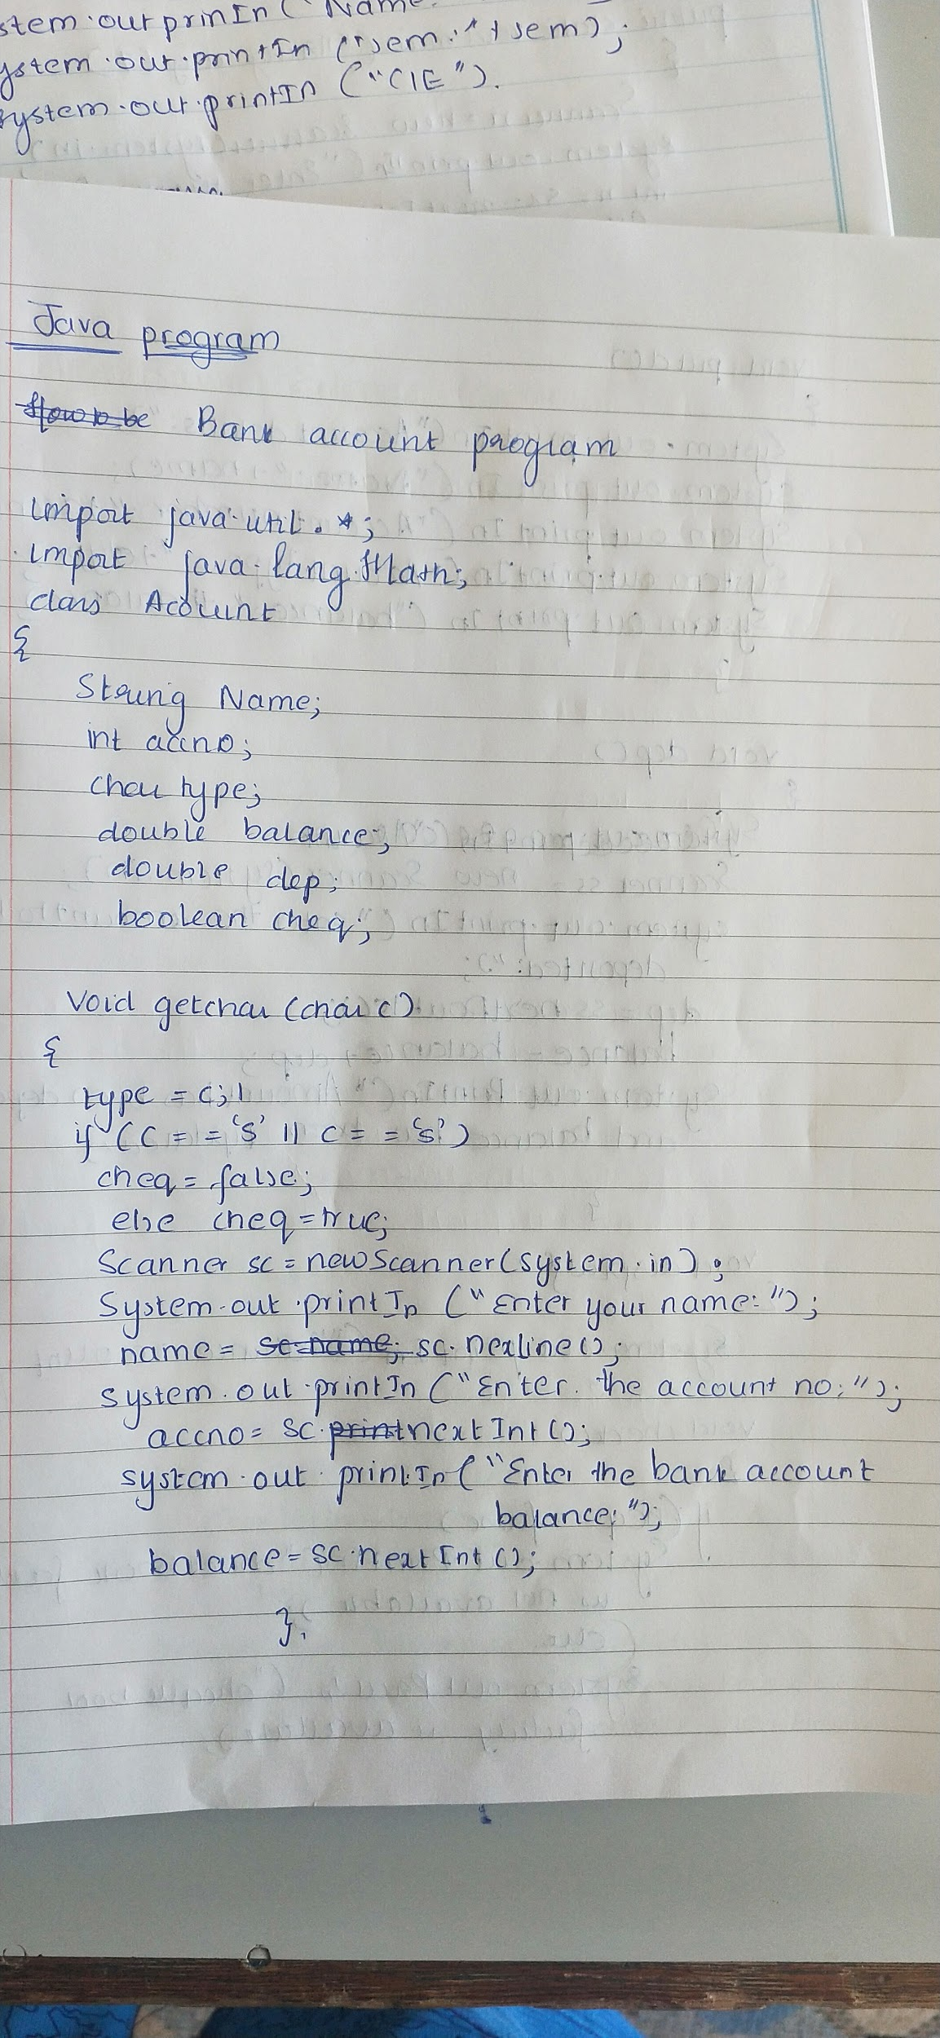

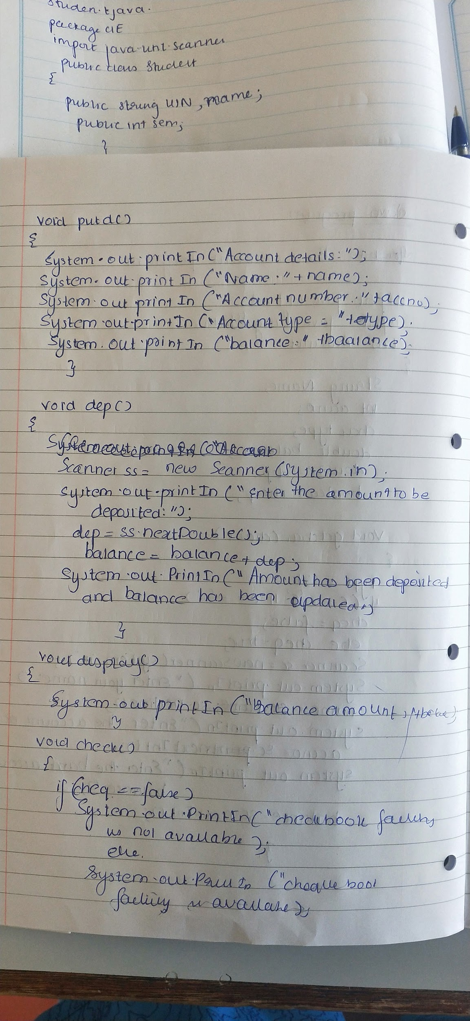

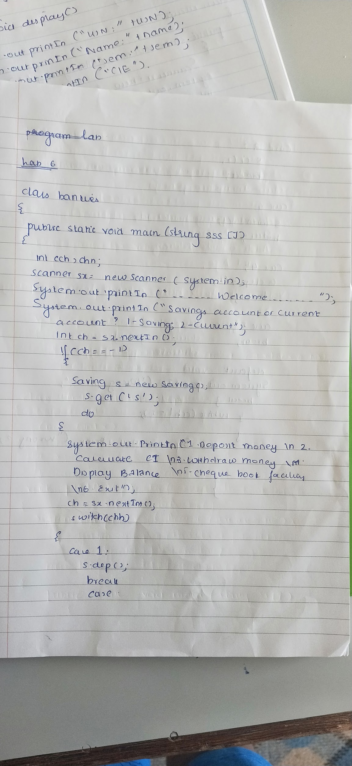

import java.util.*;

import java.lang.Math;

class Account

{

String name;

int acctno;

char type;

double balance;

double dep;

boolean cheq;

void get(char c)

{

type = c;

if(c=='s' || c == 'S')

cheq=false;

else cheq=true;

Scanner sc = new Scanner(System.in);

System.out.println("Enter your name");

name = sc.nextLine();

System.out.println("Enter the account number");

acctno = sc.nextInt();

System.out.println("Enter the current available balance in your account");

balance= sc.nextDouble();

}

void putd()

{

System.out.println("Account details");

System.out.println("Name: "+name);

System.out.println("Account number: "+acctno);

System.out.println("Account type :"+type);

System.out.println("balance: "+balance);

}

void dep()

{

Scanner ss = new Scanner(System.in);

System.out.println("Enter the amount to be deposited");

dep= ss.nextDouble();

balance=balance +dep;

System.out.println("Amount has been deposited and balance has been updated");

}

void display()

{

System.out.println("Balance amount is "+balance);

}

void check()

{

if(cheq==false)

System.out.println("Cheque book facility is not available");

else

System.out.println("Cheque book facility is available");

}

}

class Saving extends Account

{

double rate;

double s_with;

int n;

int ch;

double amt;

double term;

double pr;

void ci()

{

Scanner ss = new Scanner(System.in);

System.out.println("Enter principal deposit amount");

pr = ss.nextDouble();

System.out.println("Enter the rate of interest");

rate = ss.nextDouble();

System.out.println("Enter the term(years)");

term = ss.nextDouble();

System.out.println("Enter the number of times interest in compounded annually");

n = ss.nextInt();

amt = pr* Math.pow((1+(rate/100)),(n*term));

balance+= amt;

System.out.println("Interest is compounded and deposited; balance is updated");

}

void with_s()

{

Scanner ss = new Scanner(System.in);

System.out.println("Enter the amount of money to be withdrawn");

s_with = ss.nextDouble();

if(s_with>balance)

System.out.println("Insufficient balance");

else

{balance= balance - s_with;

System.out.println("Money has been withdrawn and balance has been updated");}

}

}

class Current extends Account

{

double c_with;

double pen;

double min;

Current()

{

pen=100;

min=500;

}

void with_c()

{

Scanner xx = new Scanner(System.in);

System.out.println("Enter the amount to be withdrawn");

c_with= xx.nextDouble();

if(c_with>balance)

{System.out.println("Insufficient funds!");

return;}

else

{balance= balance- c_with;

System.out.println("Amount has been withdrawn and balance has been updated");}

if(balance<min)

{

System.out.println("Balance is below the minimum threshold. Service penalty charge = 100/- .");

if(balance<pen)

System.out.println("Due to insufficient funds, penalty charge will be deducted from account after replenishing. Current balance is "+balance);

else

{

balance= balance-pen;

System.out.println("Penalty charge has been deducted from account balance. Current balance is "+balance);

}

}

}

}

class lab6

{

public static void main(String sss[])

{

int cch, chh;

Scanner sx = new Scanner(System.in);

System.out.println("--------Welcome----------");

System.out.println("Savings account or current account? 1- Savings; 2- Current");

int ch= sx.nextInt();

if(ch==1)

{

Saving s = new Saving();

s.get('S');

do{

System.out.println("1. Deposit money\n2. Calculate compound interest\n3. Withdraw money\n4. Display balance\n5. Cheque book facility\n6. Exit");

System.out.println("Enter your choice");

chh= sx.nextInt();

switch(chh)

{

case 1:

s.dep();

break;

case 2:

s.ci();

break;

case 3:

s.with_s();

break;

case 4:

s.display();

break;

case 5:

s.check();

break;

case 6:

break;

default:

System.out.println("Wrong option.");

break;

}

}while(chh!=6);

}

else if(ch==2)

{

Current cr = new Current();

cr.get('C');

do{

System.out.println("1. Deposit money\n2. Chequebook facility\n3. Withdraw money\n4. Display balance\n5. Exit");

cch= sx.nextInt();

switch(cch)

{

case 1:

cr.dep();

break;

case 2:

cr.check();

break;

case 3:

cr.with_c();

break;

case 4:

cr.display();

break;

case 5:

break;

default:

System.out.println("Wrong option.");

break;

}

}while(cch!=5);

}

else System.out.println("Wrong!");

}

}

